**A STUDY ON CUSTOMER PERCEPTION TOWARDS**

**ELECTRONIC PAYMENT WITH SPECIAL REFERENCE TO**

**GRACE SUPER MARKET IN CHENNAI CITY**

**Project Submitted to**

# Guru Nanak College (Autonomous), Chennai

**In partial fulfillment of the requirement**  **for the award of the**

**B.Com (General) Degree By**

**VIJAY P S**

**Reg.No. 2013141036137**

**Under the Guidance and Supervision of**

## Ms. H. Purnima Iyer,

**M.Com., M.Phil., NET.** Assistant Professor



## SCHOOL OF COMMERCE

**GURU NANAK COLLEGE (AUTONOMOUS),**

**VELACHERY, CHENNAI-600 042**

**TAMIL NADU, INDIA**

April 2023

## CERTIFICATE

This is to certify that the Project entitled “A study on customer perception towards electronic payment with special reference to grace super market in Chennai city” submitted by VIJAY P S, 2013141036137 for the partial fulfilment of Degree of Bachelor of Commerce and it is a record of original project work carried out by him under my guidance and supervision. It is his independent work and had not formed the basis for the award of any Degree / Diploma / Associate ship / Fellowship or any other similar title.

### HOD INTERNAL EXAMINER EXTERNAL EXAMINER

Date:

Place:

## DECLARATION

I hereby declare that the Project work entitled “**A study on customer perception towards E-payment with special reference to grace super market in Chennai city**” submitted by me is a record of project work done by me under the guidance of Ms. H.

Purnima Iyer, Assistant Professor, Department of B. Com (General), Guru Nanak College (Autonomous), Chennai – 600 042 and the project work has not previously formed the basis for the award of any Degree / Diploma / Associateship / Fellowship of any other

similar title.

**Vijay P S**

Date:

Place:

**ACKNOWLEDGEMENT**

I thank the Management for giving me the nice opportunity to pursue my higher education in this great institution. I thank our Principal **Dr.M.G.Ragunathan M.Sc., M.Phil.,Ph.D., FIAAB, FZSI,FSLSc, FSAB, FIAES, FICCB, FMSET, FIASN, &**

**PGDESD** for his encouragement . I convey my sincere thanks to our beloved Head of the Department **Dr.S.Amirthalingam** **M.Com., M.Phil., Ph.D. SET** for his constant support and motivation in all our endeavours.

I thank my project Guide **Ms. H. Purnima Iyer M.com., M.phil., NET**, Assistant

Professor for her excellent assistance and guidance in completing the Project. I thank our Class Mentors and other Faculty Members of Department of B. Com (General) for their assistance. I thank my beloved family members and fellow friends who have extended their support for completing this project work.

**Vijay P S**

Place:

Date:

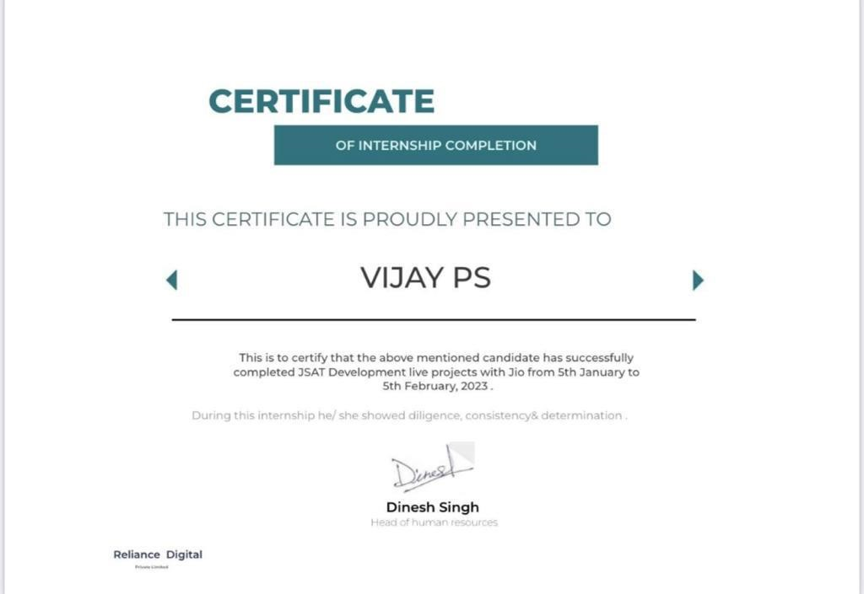

**Contents**

|  |  |  |
| --- | --- | --- |
| **Chapter No.** | **Particulars** | **Page No.** |
|  | Certificate | **ii** |
|  | Declaration | **iii** |
|  | Acknowledgement | **iv** |
|  | Internship | **v** |
|  | Contents | **Vi** |
|  | List of tables | **Vii** |
|  | List of charts | **viii** |
| **1** | Introduction and design of study | **1** |
| **2** | Review of literature | **14** |
| **3** | Conceptual framework of study | **21** |
| **4** | Analysis and interpretation of data | **28** |
| **5** | Findings, suggestion, conclusion | **52** |
|  | Bibliography | **57** |
|  | Appendix – 1) annexure - questionnaires | **58** |

**LIST OF TABLES**

|  |  |  |
| --- | --- | --- |
| **Table No** | **Titles** | **Page No** |
| 4.1 | Gender wise classification | 28 |
| 4.2 | Age wise classification | 29 |
| 4.3 | Educational Qualifications wise classification | 30 |
| 4.4 | Designation wise classification | 31 |
| 4.5 | Monthly income wise classification | 32 |
| 4.6 | Familiarity wise classification of E-payment | 33 |
| 4.7 | Usage wise classification of E-payment | 34 |
| 4.8 | Knowledge wise classification of E-payment | 35 |
| 4.9 | Comfortness wise classification of E-payment | 36 |
| 4.10 | Difficulties wise classification of E-payment | 37 |
| 4.11 | E-payment access wise classification | 38 |
| 4.12 | Classification based on usage of E-payment application | 39 |
| 4.13 | Securities based classification | 40 |
| 4.14 | Preferential wise classification of E-payment | 41 |
| 4.15 | Classification based on period of usage | 42 |
| 4.16 | Classification based on petty transaction | 43 |
| 4.17 | Classification based on modes of E-payment | 44 |
| 4.18 | Classification based on security features | 45 |
| 4.19 | Classification of E-payment based on past usage | 46 |
| 4.20 | Factors influencing the decision of customers | 47 |

**LIST OF CHARTS**

|  |  |  |
| --- | --- | --- |
| **Table No** | **Titles** | **Page No** |
| 1.6 | Payment options available while purchasing | 5 |
| 4.1 | Gender wise classification | 28 |
| 4.2 | Age wise classification | 29 |
| 4.3 | Educational Qualifications wise classification | 30 |
| 4.4 | Designation wise classification | 31 |
| 4.5 | Monthly income wise classification | 32 |
| 4.6 | Familiarity wise classification of E-payment | 33 |
| 4.7 | Usage wise classification of E-payment | 34 |
| 4.8 | Knowledge wise classification of E-payment | 35 |
| 4.9 | Comfortness wise classification of E-payment | 36 |
| 4.10 | Difficulties wise classification of E-payment | 37 |
| 4.11 | E-payment access wise classification | 38 |
| 4.12 | Classification based on usage of E-payment application | 39 |
| 4.13 | Securities based classification | 40 |
| 4.14 | Preferential wise classification of E-payment | 41 |
| 4.15 | Classification based on period of usage | 42 |
| 4.16 | Classification based on petty transaction | 43 |
| 4.17 | Classification based on modes of E-payment | 44 |
| 4.18 | Classification based on security features | 45 |
| 4.19 | Classification of E-payment based on past usage | 46 |
| 4.20 | Factors influencing the decision of customers | 47 |